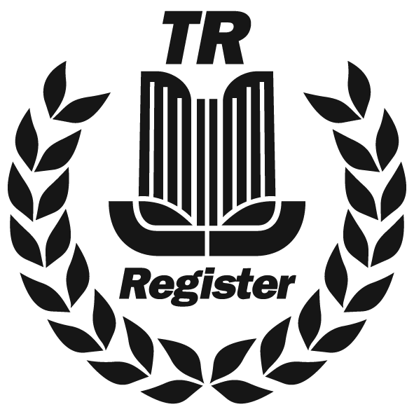 |  |  |  |  |  |  |  |  |  |  |  | Instruction to your  bank or building society  to pay by Direct Debit
Please fill in the whole form using a ball point pen and send it to:
TR Owners Club Ltd
1B Hawksworth
Southmead Industrial Park
Didcot
Oxfordshire
OX11 7HR

 |  |  |  |  |  |  |  |  |  |  |  | Service user number
 |  |  |  |  |  |  |  |  |  |  |  | 6 |  | 2 |  | 4 |  | 2 |  | 7 | 0
Name(s) of account holder(s) |  |  |  |  |  |  |  |  |  |  |  | Membership Number
Instruction to your bank or building society
Please pay TR Owners Club Ltd Direct Debits from the account detailed in this Instruction subject to the safeguards assured by the Direct Debit Guarantee. I understand that this Instruction may remain with TR Owners Club Ltd and, if so, details will be passed electronically to my bank/building society.
Bank/building society account number
Branch sort code
Name and full postal address of your bank or building society
To: The Manager |  |  |  |  | Bank/building society
Address |  |  |  |  |  |  |  |  |  |  |  | Signature(s)
 |  |  |  |  |  | Postcode |  |  |  |  |  | Date
Banks and building societies may not accept Direct Debit Instructions for some types of account
DDI2

This guarantee should be detached and retained by the payer.


The
Direct Debit
Guarantee
- This Guarantee is offered by all banks and building societies that accept instructions to pay Direct Debits
- If there are any changes to the amount, date or frequency of your Direct Debit TR Owners Club Ltd will notify you 14 working days in advance of your account being debited or as otherwise agreed. If you request TR Owners Club Ltd to collect a payment, confirmation of the amount and date will be given to you at the time of the request.
- If an error is made in the payment of your Direct Debit, by TR Owners Club Ltd or your bank or building society, you are entitled to a full and immediate refund of the amount paid from your bank or building society
– If you receive a refund you are not entitled to, you must pay it back when TR Owners Club Ltd asks you to
- You can cancel a Direct Debit at any time by simply contacting your bank or building society. Written confirmation may be required. Please also notify us.

